Digital Main Street: Futureproofing  
_________________________________________________  
  
Website analysis

Website Analysis Report for

*Greendress*



## **CURRENT WEBSITE**

*Greendress*

*Url:* [*https://www.greendress.ca/*](https://www.greendress.ca/)

**Strengths**

* Solid brand logo
* Appealing branding story
* Active blog and social media pages
* Easy website navigation
* Headers and keywords used
* Good product descriptions

**Weaknesses**

* **Incomplete meta descriptions which lead to poor Google search results**

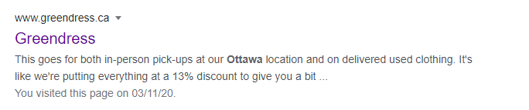

Best practice: Taking Shopify as an example, it has a short and simple meta description which describes their service “eCommerce Software – Grow Your Business”, and a brief summary of their company “Try Shopify for free, explore all the tools ….”,

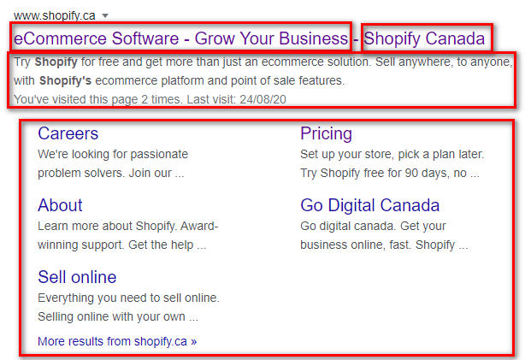

* **Too many styling colors/animations (UI/UX)**
* web pages have different background colours, different colours for buttons (ranges from orange, purple, pink, dark blue to transparent)
* too many colours take away from a solid and consistent brand identity as create a distracted user navigation experience (CTA buttons and text with darker backgrounds are hard to read)
* Greendress is an e-commerce site which requires users to input their most private information (credit/bank information)
* Consistent branding style’s used through your website creates a more trustworthy brand image and influences consistent user experience (starting from homepage all the way through to transaction completion)

Example websites:

<https://www.thredup.com/>

* Drop down menu listing product categories for easy navigation
* Font colour changes to highlight promotion
* CTA “add to cart” button is most emphasized on page
* Consistent brand style throughout entire website

<https://hiutdenim.co.uk/>

* Video links for more engaging user experience
* Very detailed product descriptions (includes fabric, materials)
* Consistent product photography

<https://www.manitobah.ca/collections/kids-collection>

* Good mix of text and visuals on page
* Clean background, easy to read text
* **Inconsistent website copy (font styling, font size, typos)**
* Use the same font family, style and size for Heading and text paragraph to increase the degree of credibility of the website
* 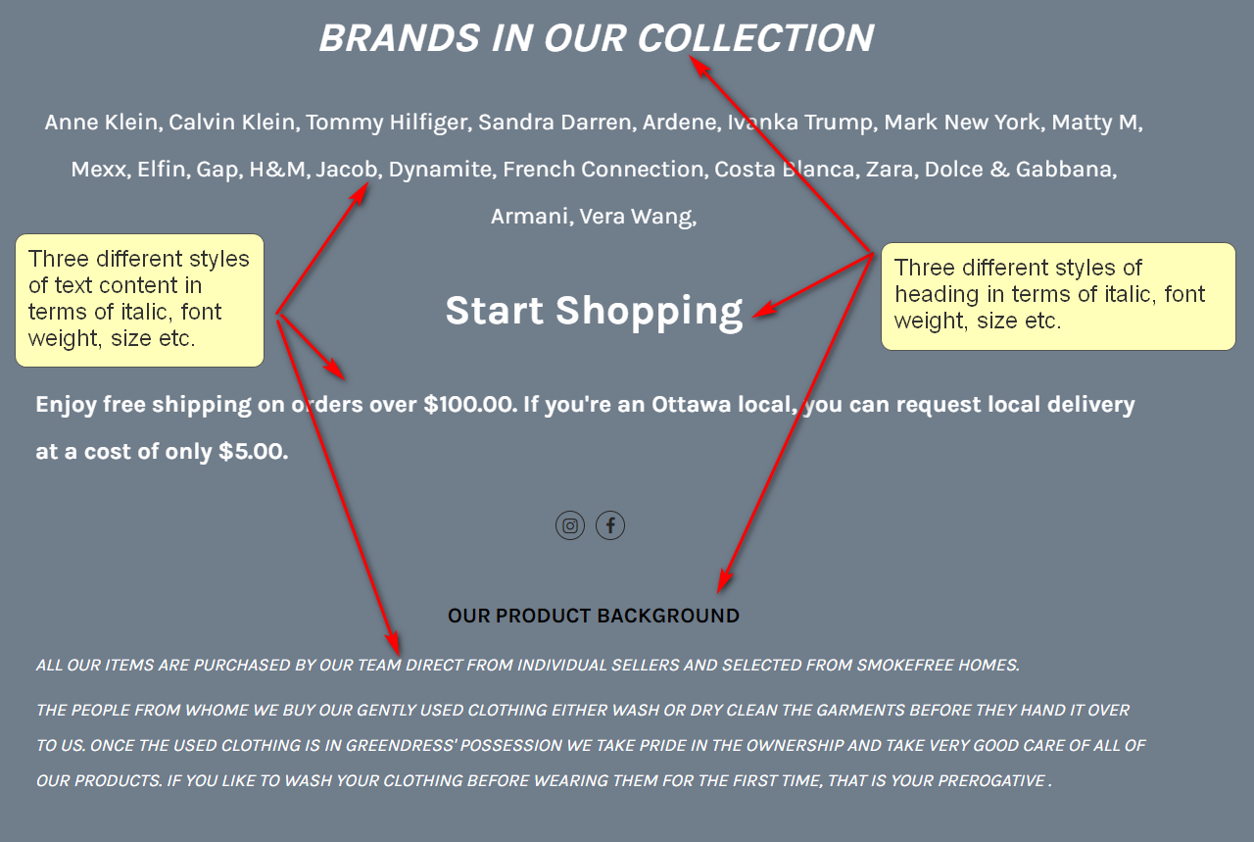

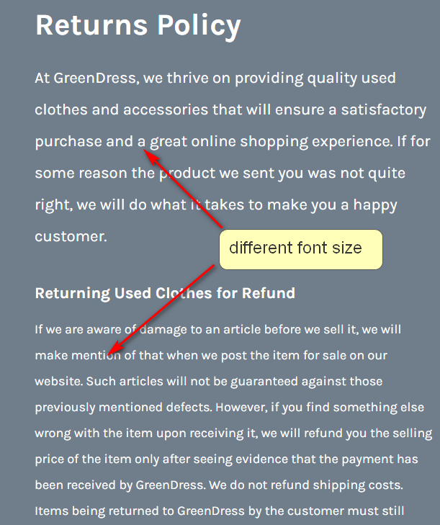

* Be more concise with text descriptions for easy navigation and user attention

*Reduce the amount of text throughout the website, since internet users are no longer fond of reading long paragraphs*



* No proper footer





* Repetitive CTA buttons (Shop Now and Let’s Shop!) both landing to same pags

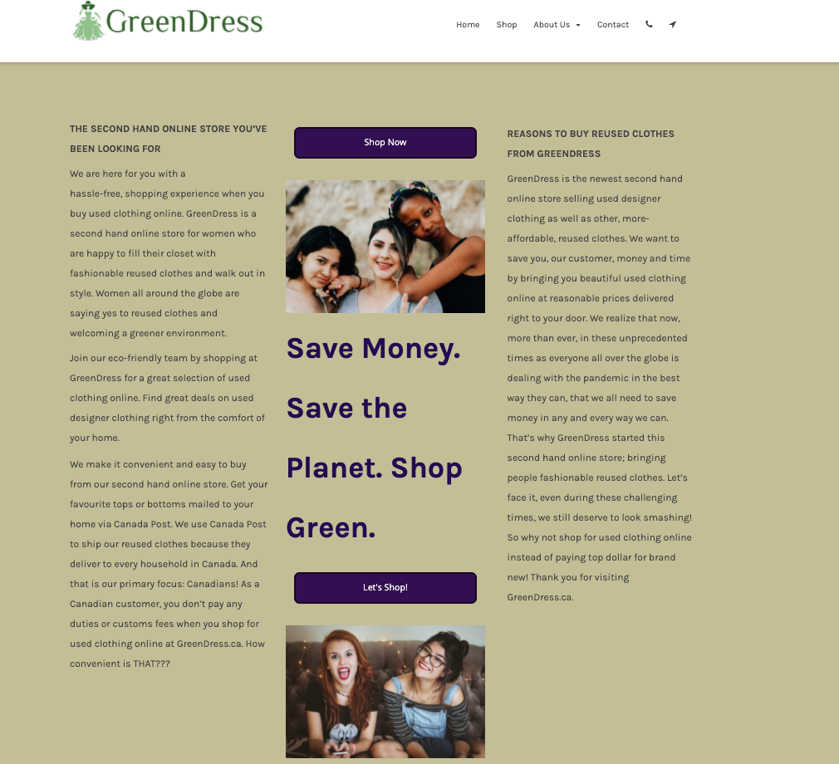

* **Inconsistent stock photos/visuals**

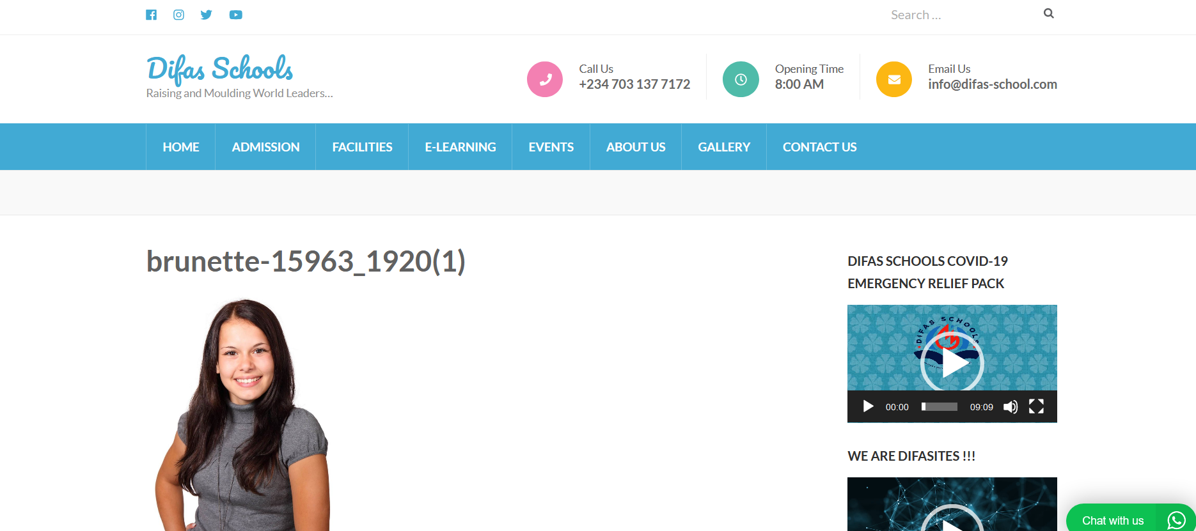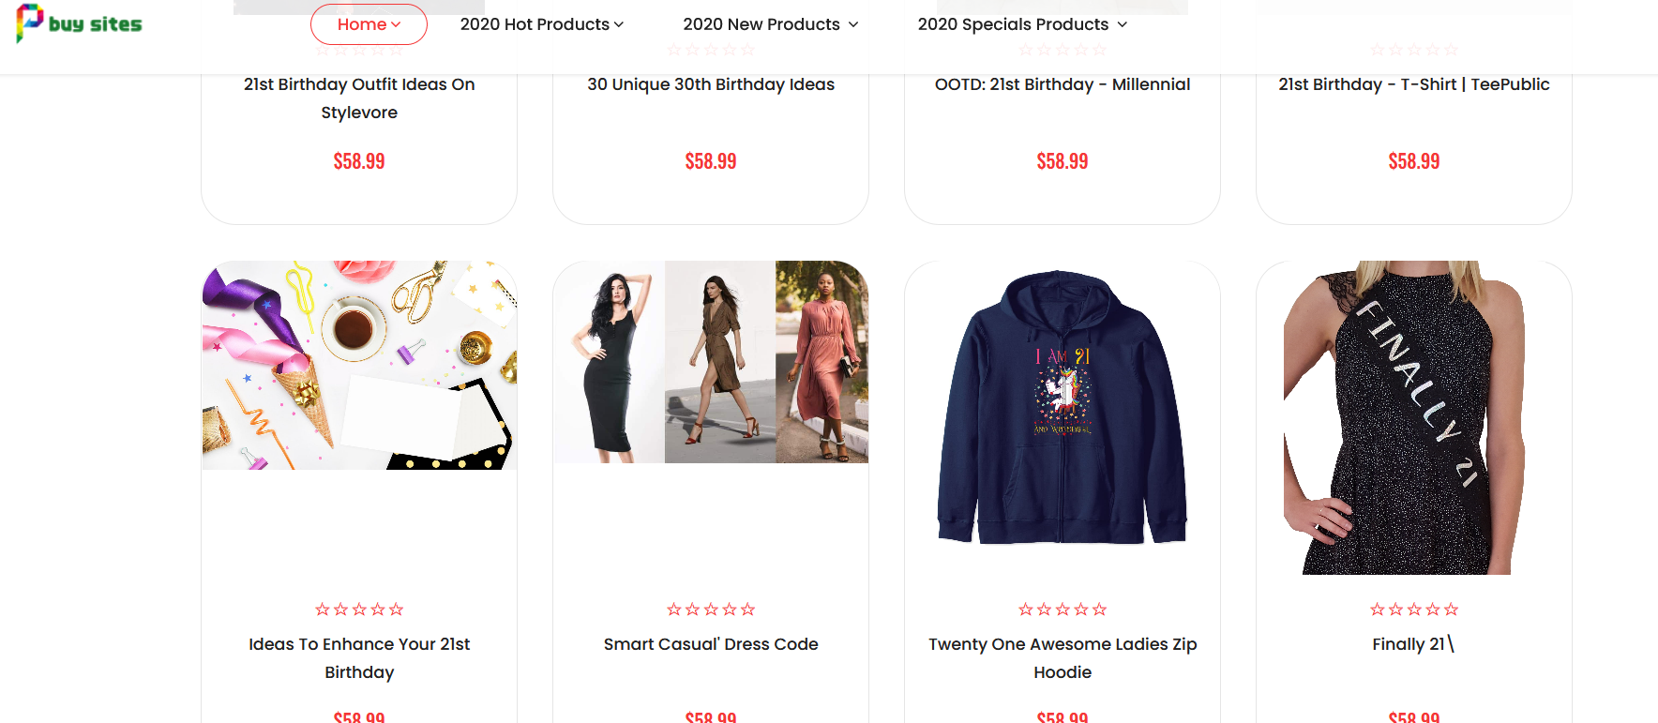

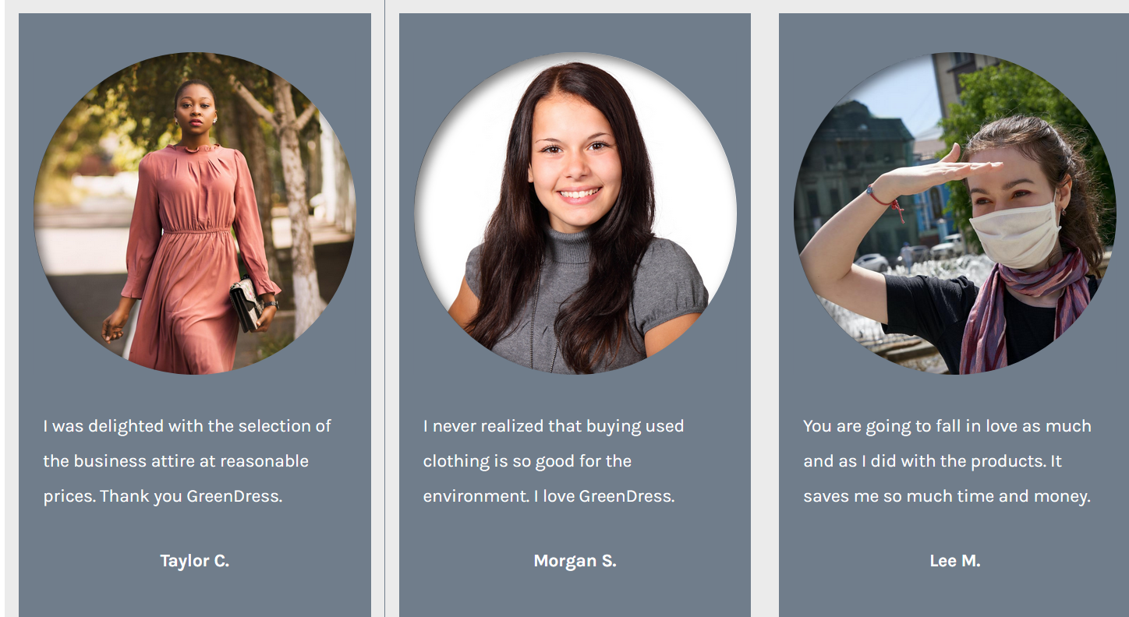

* It is better practice to repost images of customers wearing the item they purchased on Instagram than to use stock photos as customers research brand reviews on websites in depth
* **Inconsistent product photography**

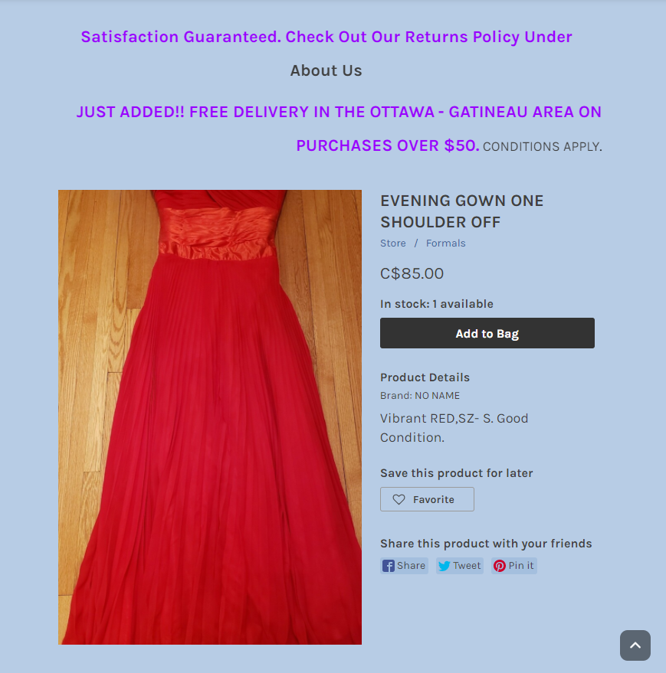

* Product is not showcased on mannequin or model, best practice in this case is to trim image so entire dress is showed
* backgrounds for products should be consistent across all products, neutral coloured background is preferred

There are many tools to fulfill this function, please refer to these tutorials. We recommend:

<https://www.remove.bg/>

<https://www.youtube.com/watch?v=_r0mp2BzAao>

Besides that, there are many others that you can find on the internet, like:

<https://www.youtube.com/watch?v=Hw0-SehGcgg>

The result should look as follows:

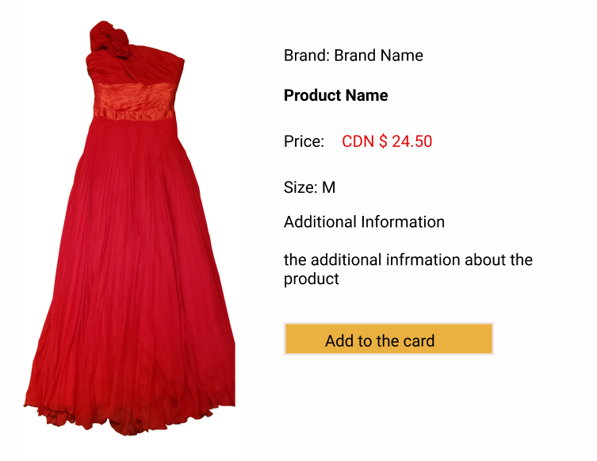

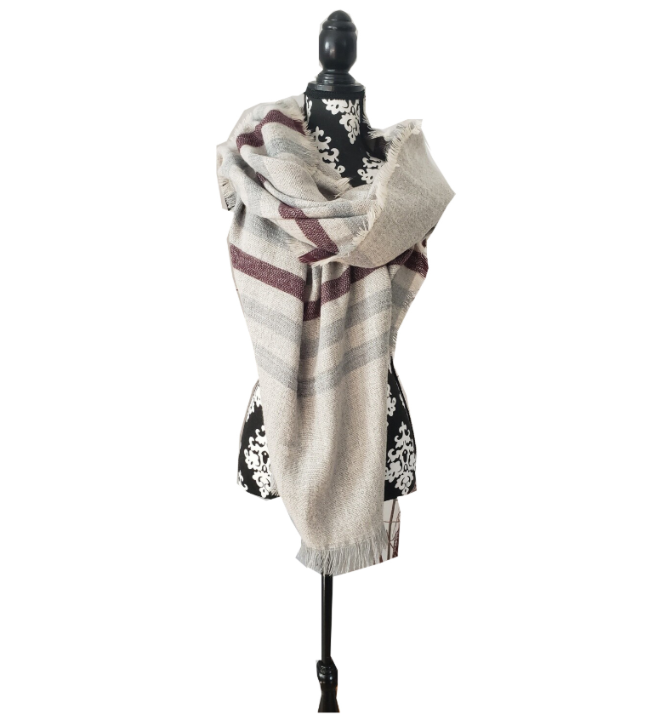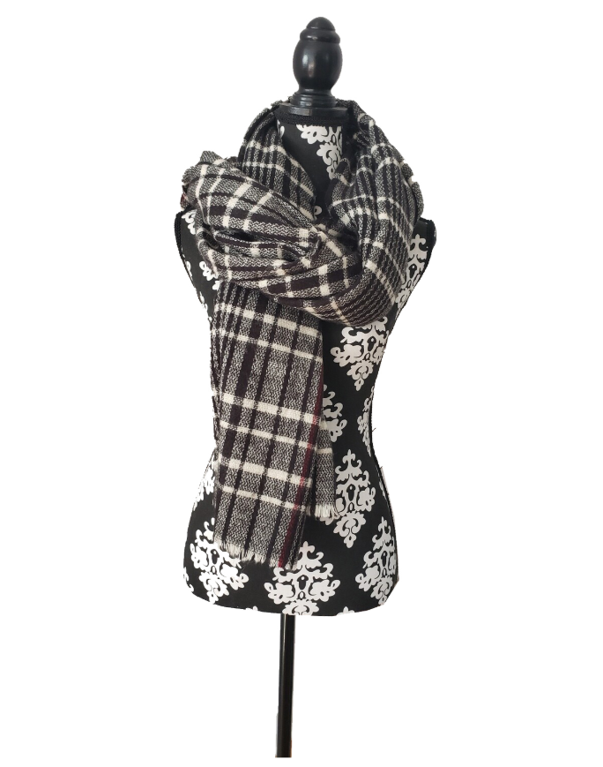

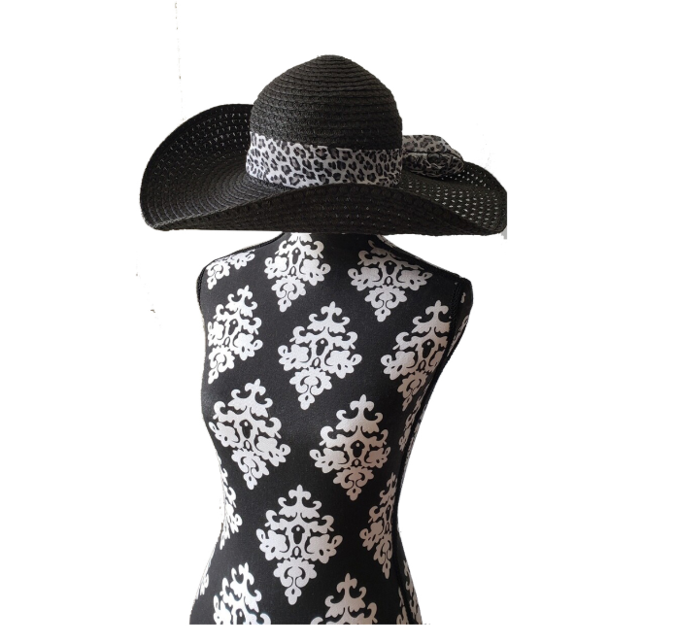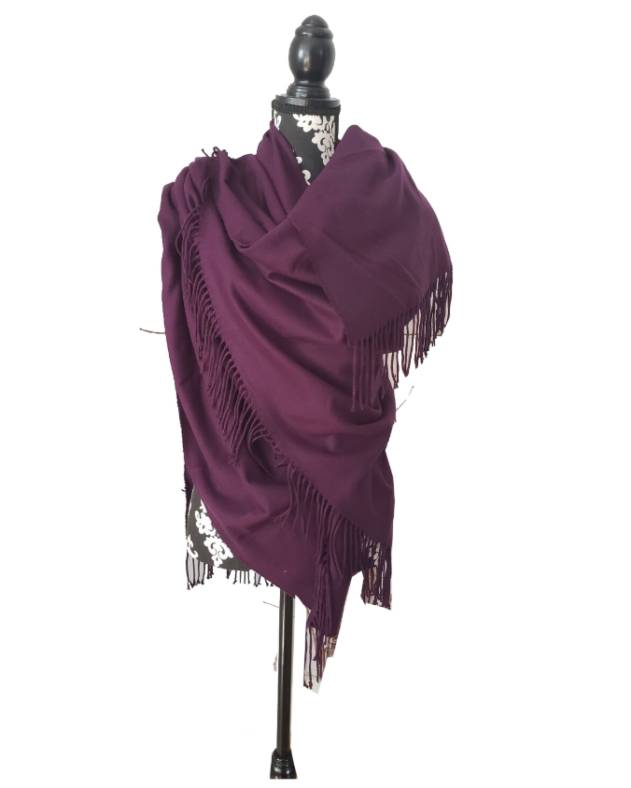

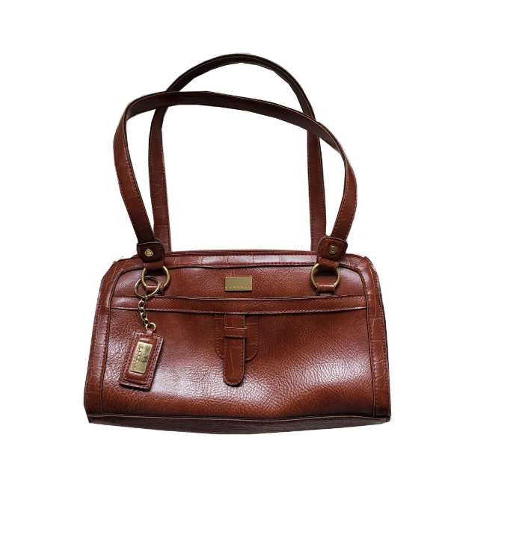

* **Some website functions do not work properly**
* The following LP link does not work

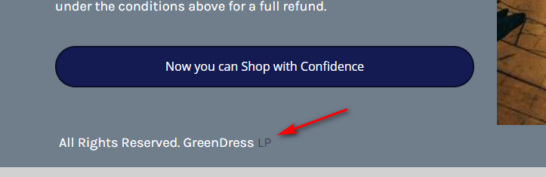

* The contact us button does not work properly

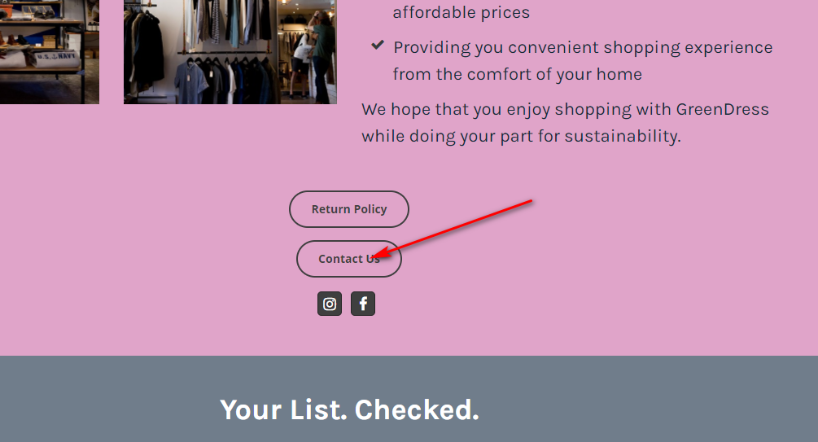

* The security level of the current website is B (test from SSL LABS)

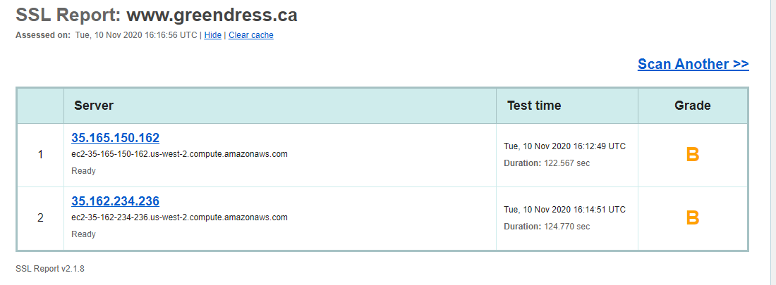

* For an ecommerce website, it is better to have “A” for security level, and it is thus recommended to migrate the website to Shopify, Squarespace or Wordpress + WooCommerce